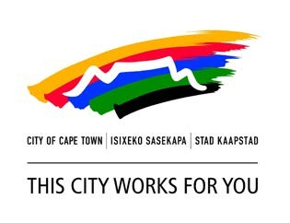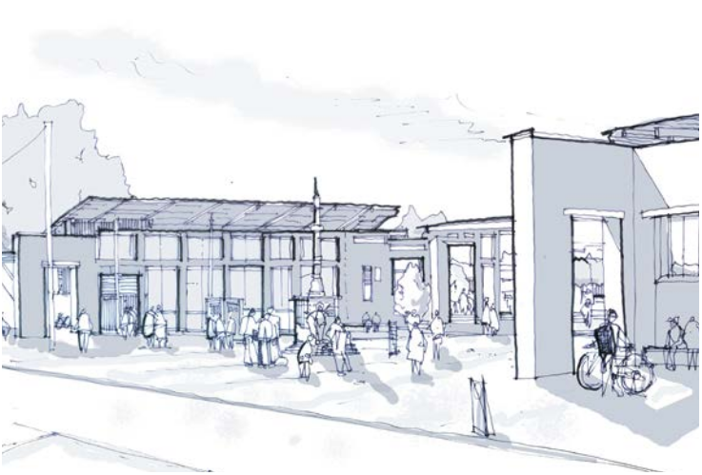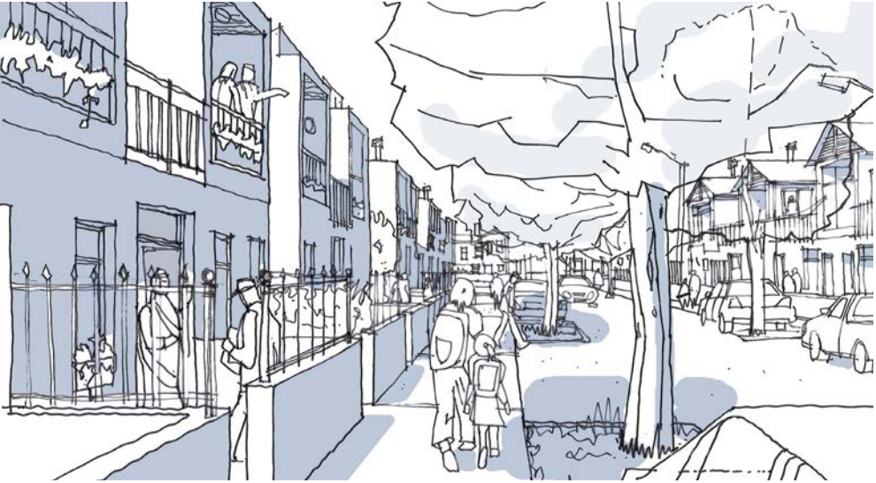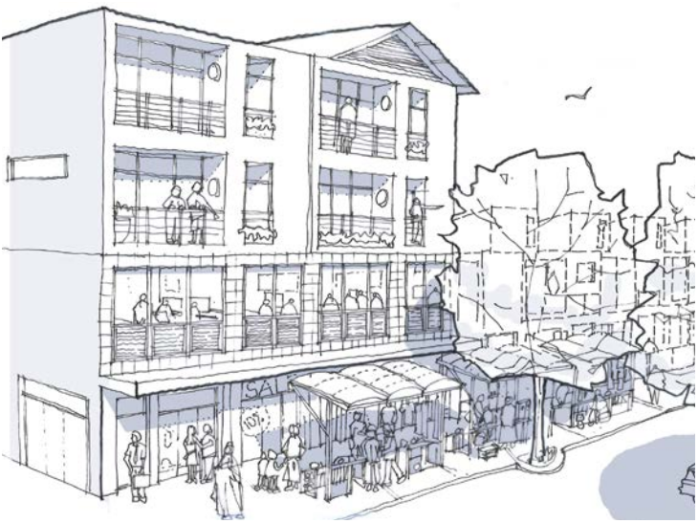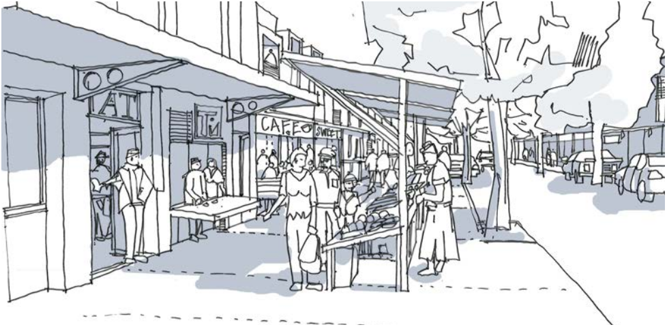

Urban Design Policy

C**CONTENTS**

**1.0 INTRODUCTION AND RATIONALE 3**

|  |  |  |
| --- | --- | --- |
| 1.1 | What is Urban Design? | 3 |
| 1.2 | Strategic Intent | 4 |
| 1.3 | Problem Statement | 5 |
| 1.4 | Desired Outcomes | 5 |
| 1.5 | Role Players and Stakeholders | 5 |
| **2.0** | **POLICY DIRECTIVE DETAILS** | **6** |
| 2.1. | Policy Parameters | 6 |

2.2. Policy Objectives and Policy Statements 6

|  |  |  |  |  |  |  |  |
| --- | --- | --- | --- | --- | --- | --- | --- |
| **3.0** | **OVER ARCHING URBAN DESIGN PRINCIPLES** | | **7** | **OBJECTIVE 8:** | | **DEVELOPMENT SHOULD PROTECT, VALUE AND ENHANCE THE NATURAL ENVIRONMENT THROUGH** | |
| 3.1 | The greater public good | | 7 |  | | **SUSTAINABLE DESIGN 15** | |
| 3.2 | The “whole” above the “parts” | | 7 | **OBJECTIVE 9:** | | **DEVELOPMENT SHOULD RESPECT AND ENHANCE** | |
| 3.3 | Identity, Context and Place making | | 7 |  | | **THE HERITAGE, CHARACTER AND UNIQUE IDENTITY**  **OF THE CITY AND ITS NEIGHBOURHOODS** | |
|  |  | |  |  | | **16** | |
| **OBJECTIVE 1:** | | **ENSURE THAT DEVELOPMENT CONTRIBUTES** | | **4.0** | **IMPLEMENTATION** | | **17** |
|  | | **POSITIVELY TO THE URBAN STRUCTURE OF THE CITY** | |  |  | |  |
|  | | **TO CREATE INTEGRATED AND LEGIBLE PLACES AND** | | **5.0** | **POLICY EVALUATION, MONITORING AND REVIEW** | | **18** |
|  | | **NEIGHBOURHOODS 8** | | 5.1 | The effectiveness of the policy in facilitating approvals processes | | 18 |

**OBJECTIVE 4: ENSURE OPPORTUNITIES AND AMENITIES ARE ACCESSIBLE AND THAT PEOPLE CAN MOVE ABOUT EASILY AND EFFICIENTLY 11**

**OBJECTIVE 5: PROMOTE DEVELOPMENT INTENSITY, DIVERSITY AND ADAPTABILITY 12**

**OBJECTIVE 6: ENSURE ENCLOSURE AND POSITIVE INTERFACES ONTO THE PUBLIC REALM 13**

**OBJECTIVE 7: DEVELOPMENT SHOULD RECOGNISE AND RESPOND APPROPRIATELY TO INFORMALITY 14**

**OBJECTIVE 2: ENSURE THAT DEVELOPMENT CONTRIBUTES TO IMPROVED QUALITY OF THE PUBLIC REALM AND PUBLIC SPACES 9**

**OBJECTIVE 3: ENSURE THAT DEVELOPMENTS CONTRIBUTE TO THE CREATION OF SAFE AND SECURE COMMUNITIES**

**10**

5.2 The effectiveness of the policy in improving the quality of the urban environment 18

**6.0 GLOSSARY, DEFINITIONS AND TERMINOLOGY 19**

Acronyms and Abbreviations 21

References 21

**7.0 ACKNOWLEDGEMENTS 22**

**1.0 INTRODUCTION AND RATIONALE**

Internationally it has been recognised that design, and more specifically urban design, can add value to development processes and play a positive role in urban transformation. This potential has been formally recognised in the Cape Town Spatial Development Framework (CTSDF) which guides the development of the city and which already includes many sound urban design principles. Policy 42 of the CTSDF established the mandate for the creation of an urban design policy to articulate how the high level policy objectives and principles of the CTSDF and UDP can be achieved at the local level through development. The intention of this Policy is to guide the design process and formulation of development proposals so as to address the segregated nature of the city inherited from apartheid and make Cape Town safer, more economically prosperous, socially inclusive and environmentally sustainable, while also making it look and work better for all those who live in and visit the city.

**1.1 What is Urban Design?**

Urban design is concerned with the process of creating holistic and sustainable human settlements. It is a practice which straddles the disciplines of spatial planning, architecture, landscape architecture, road and street design and environmental design. It is focussed on the shaping of the built environment in response to the natural, physical, social and economic factors which influence the form of human settlement. It seeks to add value, through the medium of design, for the good of the environment in its totality and for all who inhabit it, specifically the old, the young, the disabled and the poor whose ability to tap into the benefits and opportunities of urban living is limited.

Urban design applies equally to the organisation of urban, rural, natural and cultural landscapes. It operates across scales, concerning itself as much with overall urban structure of the city as it does with the interface of individual buildings and the detailing of materials. It’s as much about getting the small, individual instances of good design right as it is about managing and guiding the processes of urban formation over time.

Urban design is about the process of place making. It is rooted in social practice, time and space. It is through the application of design that the qualities of a place are transformed, given purpose, become relevant, and have meaning. In this regard the quality of the public domain is of

paramount importance because people’s quality of life and the identity of the city is informed and transformed by these qualities which they experience on a daily basis.

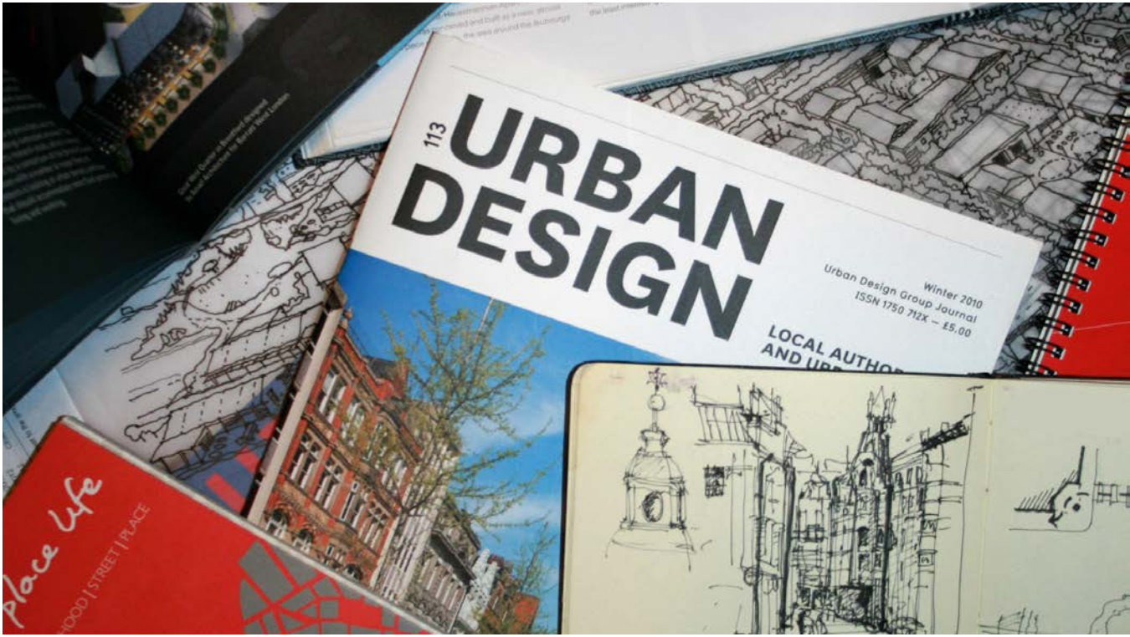

What distinguishes urban design from other development related activities is that it seeks to introduce the creative process of spatial design into land development processes. It is focused on how the design process and the arrangement of built form can enhance the public environment and the interface between the public and the private realms. Urban design is not about the production of static solutions produced by a single person or one master mind. It is instead a collaborative and fluid process undertaken by a range of role players and professionals in response to real and perceived needs and opportunities which change over time.

*“Urban design is the collaborative and multi- disciplinary process of shaping the physical setting for life in cities, towns and villages; the art of making places; design in an urban context. Urban design involves the design of buildings, groups of buildings, spaces and landscapes, and the establishment of frameworks and processes that facilitate successful development.”*

Urban Design Group UK,2011

NATIONAL LEGISLATION AND POLICY

MSA

NEMA

NHRA NBR

NTA

**1.2 Strategic Intent**

Municipal Systems Act National Environmental

Management Act

National Heritage

Resources Act

National Building

Regulations

National Transport

Act

One of the strategic objectives of the Policy is to improve alignment with the government’s programme of action and the IDP in particular. The strategic focus areas (or ‘pillar’) that inform the policy include:

PROVINCIAL ORDINANCES AND POLICY

Strategic FocusArea 1 -The Opportunity City: creating an economically

PSDF

LUPO RAG

enabling environment in which investment can grow and jobs can be created by virtue of providing greater certainty to developers in

Provincial Spatial

Development Framework

Land Use Planning

Ordinance

Road Access Guidelines

respect of the City’s expectations; by fast-tracking the assessment of applications; providing transparency and predictability to investors; clarifying the submission requirements and the basis for assessment of proposals; and facilitating consistency in decision-making.

In recognition that development has the potential to change the way the city is structured and can have an impact (positive or negative)

MUNICIPAL BY-LAWS AND POLICY

INTEGRATED DEVELOPMENT PLAN (IDP)

on the collective, or public, environment, it is the City’s duty to develop policies to guide and regulate development and then assess development applications against these policies through the land use planning and building plan approvals process. This authority is confirmed through Section 36 of the Land Use Planning Ordinance where a proposal must be assessed in terms of its desirability. It is also confirmed through Section 7 of the National Building Regulation and Standards Act which allows for refusal of applications on certain grounds. In both pieces of legislation, what has not been defined are the criteria which should be used for determining such desirability.

The CTSDF and District Plans already include many sound urban design principles at the scale of the city which can be used to assess desirability. The intent of this Policy is to focus on the local level, the scale of the site , precinct or neighbourhood.

Policy Environment

|  |  |  |
| --- | --- | --- |
| Linkage mechanisms / tools | | |
|  | **POLICIES**  sectoral policies / strategies /  guidelines  URBAN DESIGN  SKY BRIDGES TALL BUILDINGS AND OTHERS  **REGULATIONS**  Overlay zones (additional development rights to base zone) |  |

Spatial Plans

(set development objectives, strategies, guildelines and action plans)

SPATIAL POLICY AND REGULATION

Cape Town SDF

Strategic spatial development goals and principles

OTHER STRATEGIC POLICY

Economic Development Strategy

Social Development Policy, etc

Regulatory Environment

Cape Town

Zoning Scheme

(base zones, land use rights, development rules and provisions)

DISTRICT PLANS

LOCAL AREA PLANS

The above diagram illustrates that the Urban Design Policy operates primarily at the municipal level and functions as a linking mechanism between the regulatory environment and the policy environment. The policy also relates to the Land Use Planning Ordinance and the National Buildings regulations which sit under different spheres of government.

**1.3 Problem Statement**

Two observations of the statutory approvals process have guided the way in which the Policy has been formulated:

**Observation 1:**

It has become increasingly apparent that, although high level spatial planning and other regulatory frameworks are in place, many development applications that are submitted to the City could be better conceptualised, particularly when measured against the impact they have on the public domain. In many strategic cases urban design considerations are absent from the conceptualisation of a development proposal. While the impacts of individual developments tends to be localised, the collective impact of many poor design decisions over time has significant implications for how the city functions an is experienced.

*The implications are that:*

*• the urban structure of the city is not legible and*

*neighbourhoods are not integrated;*

*• development detracts from the quality of the public realm*

*and public spaces;*

*• development proposals do not promote safe and secure*

*communities;*

*• opportunities and amenities are inaccessible and movement*

*is difficult and inefficient;*

*• development lacks critical mass of intensity, diversity and*

*adaptability;*

*• the public realm lacks enclosure and positive interfaces;*

*• informality is not recognised and responded to in*

*development proposals;*

*• development devalues and threatens the natural*

*environment; and*

*• development undermines the heritage, character and unique*

*identity of the city and its neighbourhoods.*

**Observation 2:**

It has also been observed that in many instances applicants invest large amounts of time and money into developing proposals which are not informed by basic urban design considerations and as a result respond inadequately to the site and its context. In instances where the impact of these proposals on the public realm is regarded as negative, applicants are required to amend their proposals before approval is granted. This can have severe time and cost implications for applicants, as typically the proposals which have been submitted for approval have progressed so far along the design process and are resolved to such a high level of detail that they cannot be easily amended without a radical revisiting of the concept. This results in frustrations for all parties, which is undesirable and unproductive.

**1.4 Desired Outcomes**

The Policy has three desired outcomes.

1. The Policy seeks to introduce urban design thinking into the planning and preparation of development proposals. It promotes an evidence based mode of practice through which development proposals are unpacked as a logical series of design decisions during which the requirements of the applicant are fulfilled and the public environment is improved. Ultimately, when a development proposal is clearly presented, well motivated and communicated as the conclusion of a considered design process, then it can be easily understood and assessed by officials.

2. The Policy assists in informing desirability by providing a transparent framework of urban design principles and objectives against which development applications will be assessed. Rather than prescribe a rigid set of design rules which could stifle creativity and potentially undermine development, the Policy sets out the most fundamental urban design objectives and criteria which proposals should comply with. The Policy focuses specifically on those criteria that have a potential impact on the public environment and more specifically the interface conditions between the public and the private realms.

3. The Policy objectives and principles together form a basis upon which applicants are invited to engage with the City in early pre-submission consultation. During these engagements applicants will be advised on how their proposals should be developed and packaged to meet the City’s requirements.

**1.5 Role Players and Stakeholders**

The Urban Design Policy has been written for developers, built environment professionals and City officials involved in the design, assessment and implementation of development proposals. It will be used primarily by the City of Cape Town’s Planning and Building Development Management Department (PBDM) and the Environmental Resource Management Department (ERM) to facilitate their statutory development control functions. The powers and functions of these departments are captured in the system of delegations. The Spatial Planning and Urban Design Department will use the policy to comment on applications in support of the functions of the regulatory departments.

**2.0 POLICY DIRECTIVE DETAILS**

**2.1. Policy Parameters**

The Policy falls within Strategic Focus Area 1: The opportunity city: Programme 1.1(e): Planning and regulation programme: Supportive legal frameworks. As such it provides substantive guidance on the implementation of existing plans and frameworks.

The principles of good urban design apply across the different scales of planning and to all aspects of urban development. It is about “understanding the bigger picture” and also about “getting the detail right”. Good urban design principles are already embedded in the CTSDF and District Plans and the purpose of the policy is to establish performance criteria to ensure that the City’s spatial vision as articulated in the CTSDF is realised at the local level.

The City acknowledges that Cape Town consists of many different realities and urban conditions. The policy objectives and policy statements therefore remain at the level of principle and must be applied , with discretion, to the context within which a development is located. The principles have thus been distilled to the most basic and fundamental for achieving good urban design in practice.

On this basis it should be clear that not all policy statements will apply to every development proposal. The application of any policy objective or policy statement will depend on the nature and scale of the development proposal and the sensitivity of the receiving context. Applicants and officials must apply their minds to the particular characteristics of the site and nature of the proposal and exercise discretion in the design or assessment of the proposal.

Although all development proposals should be the result of good design, the application categories specifically listed below in text box will be required to demonstrate compliance with the Policy and be assessed against the criteria set out in the policy objectives and policy statements which form part of Chapter 3.

Development categories which will be subject to the Policy

1. Proposals that deviate from the approved forward planning vision and spatial policies of the City at local area scale;

2. new township establishments or where the application includes new subdivisions into more than 20 urban land units;

3. Where regeneration of a site exceeding 1Ha is envisaged;

4. proposals including the creation of new public space and/or public or community facility;

5. proposals adjacent to or including watercourses or wetlands;

6. where Site Development Plans are required for the following group of applications:

a. shopping centres (from neighbourhood to district scale centres);

b. commercial developments exceeding a bulk of 1000m2;

c. industrial developments exceeding a bulk of 5000m2; and d. sectional title developments of more than 10 units; and

7. where a delegated official considers that an application has the potential to have a significant negative impact on the public realm.

Textbox 2.1

Whilst there is a degree of discretion in any urban design assessment, the Policy Objective and Statements provide an objective framework through which proposals will be assessed. In terms of Section 2.0 (Policy Directive) 2.1 (7) deviations from the policy for sound and considered reasons may only be permitted by the District Manager. Applicants are invited to engage the City at the inception of a project to determine whether the Policy would apply to their project.

**2.2. Policy Objectives and Policy**

**Statements**

The Policy is guided by three over arching principles which inform nine objectives. Each policy objective is then supported by a number of associated policy statements which provide the criteria which should inform the design of development proposals and also form the basis through which development applications will be assessed. The Policy is structured in such a manner that each policy objective is dealt with on a single page.

The policy objective is located at the top of the page with a simple description of why the objective is important in the orange box. This is followed by the policy statements which give substance to the policy objective. The key words related to each policy statement have been highlighted with a background colour for ease of reference. Wherever possible a list of related plans and policies is provided in a grey box at the bottom of the page in order to assist applicants with accessing more detailed information.

**3.0 OVER ARCHING URBAN DESIGN PRINCIPLES**

This Policy is underpinned by the spatial development principles set out in the CTSDF (2012, Section 1.2.3, pg 9). These should be used to guide the development and assessment of proposals with particular emphasis on the principles listed below.

**3.1 The greater public good**

Cities are places where people come together to enjoy the benefits of living and working in close proximity to others. Through the arrangement of activities, built form and open space, urban development must ensure that these benefits are accessible to all and generate further opportunities for social and economic development. Sustainable development can only result when there is an improvement in the environmental, social and economic situation, and whether driven by the public or private sector, the objective should always be to create a better city for all to enjoy and benefit from.

**3.2 The “whole” above the “parts”**

Urban environments are constantly under pressure to change and meet a multitude of often conflicting demands. Due to the complex and interrelated nature of urban environments, the optimisation of one component of an urban system could have detrimental impacts on other related parts of the same system. In order to maintain a dynamic equilibrium it is therefore necessary to focus on the overall performance of the whole, not the optimisation of individual parts. Urban design therefore seeks to take an informed and balanced approach to the short term needs of today and the long term opportunities, capacities and limitations of the environment and future generations.

**3.3 Identity, Context and Place making**

The city’s identity changes over time through the transformation of the natural, historical, social and economic environments. This change results from thousands of independent decisions and actions at project level. Every design proposal should appreciate this context. “Place making” is conscious of this layered identity and places people and their experience of their urban environment at the centre of the design process. Without thorough analysis and an understanding of how a proposal fits into the bigger picture, any development initiative is at risk of being irrelevant, inappropriate or of compromising the performance and quality of the whole.

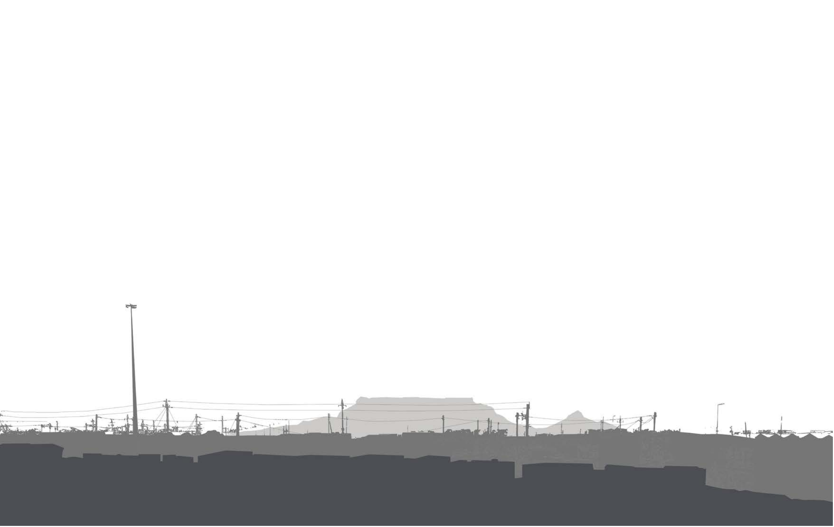

7

**OBJECTIVE 1: ENSURE THAT DEVELOPMENT CONTRIBUTES POSITIVELY TO THE URBAN STRUCTURE OF THE CITY TO CREATE INTEGRATED AND LEGIBLE PLACES AND NEIGHBOURHOODS**

*Urban structure refers to the organisation of space, infrastructure, functions and activities within a settlement. Structure is an important enabling tool across all scales of development. It gives character to place and tends to be permanent once implemented. It is vitally important to get it right at inception, because a poor structure cannot be improved upon later with the best designs of individual buildings. Individual proposals should thus align and support positive urban structure. Therefore:*

PS1.1. When compiling development proposals, the logic of the should be communicated in

underlying urban structure

a clear, rational and well-articulated manner. Proposals should demonstrate how a new development into and

fits

contributes positively

to its surrounding context, addresses spatial, economic and social segregation, improves

and creates more urban places.

integration

legible

PS1.2. When laying out a new development,

facilities and public institutions together or locate them along the higher order structuring routes to the spatial structure (as opposed to embedding them within a residential neighbourhood). Where possible, associate

reinforce

cluster community

public facilities with high quality open spaces to create civic precincts where building frontages define the street and the public realm.

PS1.3. The location of must be considered early on in the development design process and should reinforce the primary spatial structure and

utility services

not determine or limit

urban form. Elements such as detention ponds and electrical substations must be such that they

intentionally located

do not create movement blockages, inconvenience people or create dead frontages where active interfaces are required.

• Cape Town Spatial Development Framework (CTSDF)

2012

• District Spatial Development Plans and Environmental

Management Frameworks 2012

• Minimum Requirements for Vehicle Access 2009

• Catchment Management Plans 2009

RELATED POLICIES / INFO

Intensification of development associated to route

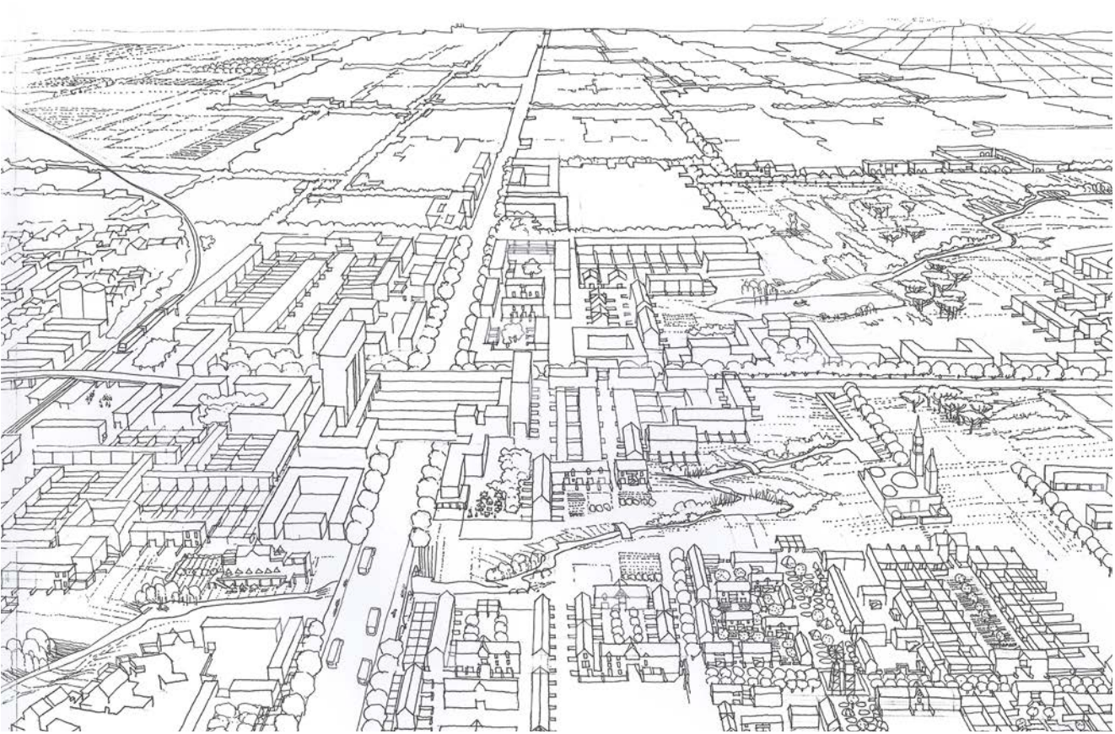

Cluster higher order community facilities in nodes

Natural systems integrated into the urban environment

**OBJECTIVE 2: ENSURE THAT DEVELOPMENT CONTRIBUTES TO IMPROVED QUALITY OF THE PUBLIC REALM AND PUBLIC SPACES**

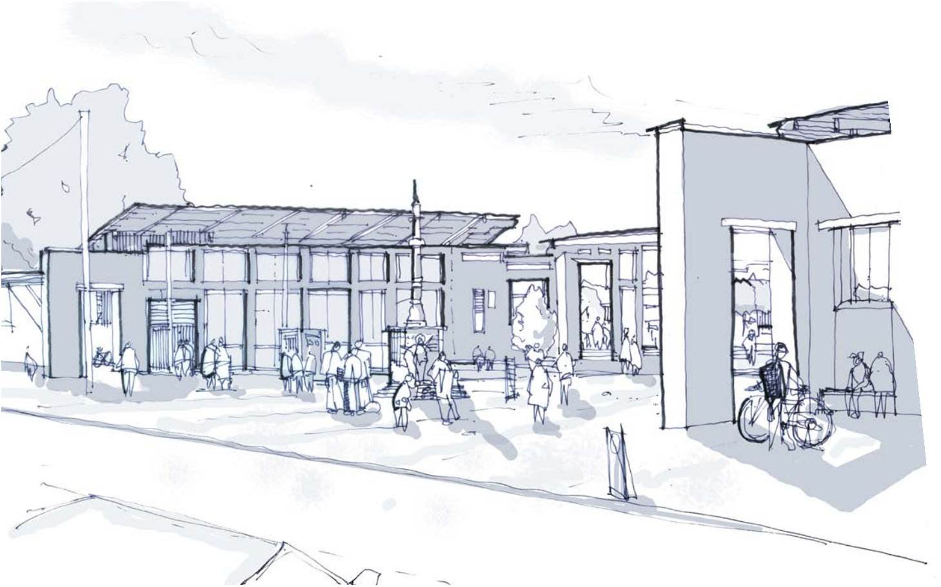

*It is critical to ensure that the public realm is of a high quality as these are the environments which people use and experience collectively and on a daily basis. The quality of the public realm is determined by how well the public space is designed, built and maintained as well as by the quality of the interface of surrounding buildings with the public realm. Therefore:*

PS2.1. and scaled and configured to suit the functions for which it is planned (e.g. regular geometries and to meet standard dimensions required for active recreation). Open space should never be residual or left over space.

Open space must always be created intentionally

PS2.2. Where appropriate public spaces should be community facilities, higher

associated

with public institutions,

density developments, water courses and public roads and these public spaces should be

overlooked.

PS2.3. Avoid arranging buildings or erven such that the rear

/ backs of private property face onto the public realm (streets or public open spaces) unless there is certainty that the buildings will be designed to provide a

positive

interface

onto the space.

PS2.4. public spaces to be robust and durable with low maintenance hard and soft landscaping and street furniture that is resistant to vandalism. Consider

post implementation maintenance and management

Design and detail

through the design process. • Boundary Walls and Fences Policy, 2008

RELATED POLICIES

• Development Management and Information Guideline

Series – Booklet 7 Landscape Plans

**OBJECTIVE 3: ENSURE THAT DEVELOPMENTS CONTRIBUTE TO THE CREATION OF SAFE AND SECURE COMMUNITIES**

*Developments should create the sorts of conditions where people are less exposed to risks and hazards, where levels of safety are increased, the occurrences of vandalism are reduced, criminal and violent activities are more difficult to commit and perpetrators of crime are easier to identify. This will directly improve people’s quality of life in that they will feel safer, be less exposed to a danger and violence and consequently their perceptions of crime and the fear of crime is reduced. The following Policy statements should therefore inform design proposals:*

PS3.1. and increase passive surveillance of the public realm by: creating routes that have simple straightforward geometries; locating many doors, windows, balconies and terraces along the public interface; providing

Optimise visual connections

a mix of complementary land uses wherever possible; and creating simple designs that do not create blind spots and entrapment spaces.

PS3.2. Consciously organise space and activities to

reduce the risk

people, particularly the poor and vulnerable, are exposed to. Keep developments out of areas succeptable to sea level rise and flooding, prepare for climate change, avoid hazardous areas, encourage slower traffic speeds where appropriate and ensure that people can safely cross busy roads and railway lines.

balconies and windows provide overlooking from adjacent buildings

straight and simple geometries increase sight distances and levels of surveillance

• Draft Safe Neighbourhoods Guidelines, 2012

RELATED POLICIES / INFO

• Violence Prevention through Urban Upgrading (VPUU) Safety Principles, 2009

• Gated Development Policy, 2007

• Boundary Walls and Fences Policy, 2008

buildings located close to the street edge to define the street and encourage overlooking

visually permeable / low front boundary walls ensure surveillance of the street at ground level

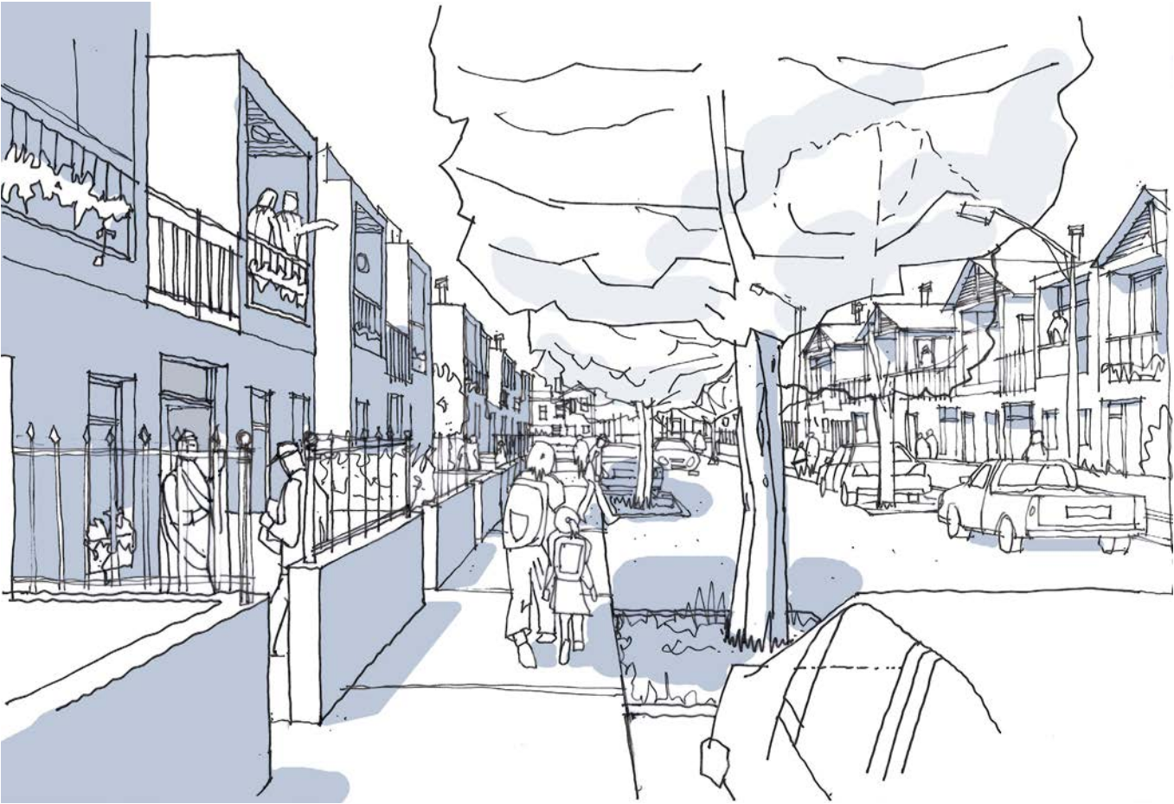

on-street car parking encourages people to keep their eyes and ears on the street

**OBJECTIVE 4: ENSURE OPPORTUNITIES AND AMENITIES ARE ACCESSIBLE AND THAT PEOPLE CAN MOVE ABOUT EASILY AND EFFICIENTLY**

*Vibrant urban places create the conditions where the movement of both goods and people is easy, convenient and efficient. They also offer choice by providing different routes and travel options for accessing opportunities, goods and services. Therefore:*

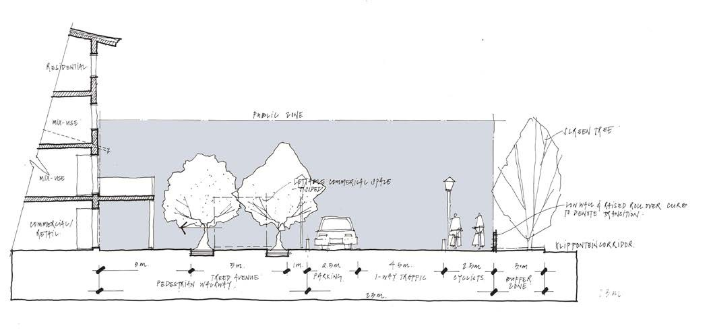

PS4.1. between and through existing and new neighbourhoods to

Provide spatial connections

create, reinforce and

where necessary, the hierarchy of movement routes to achieve greater levels of integration, spatial continuity and improved permeability for pedestrians,cyclists and people with disabilities.

transform,

PS4.2. Recognise the and how development proposals can change the way people move.

Address dominant pedestrian desire lines

generators of movement

by providing linkages and generous landscaped sidewalks around and to important destinations that attract high levels of pedestrian traffic. Further access to all

ensure universal

buildings, transport facilities and along popular pedestrian routes;

PS4.3. must be considered from the beginning of the design process when developments are likely to attract public patronage (shopping centres, public facilities and public transport interchanges). The facilities provided must cater for the different needs of end users (residents, staff and visitors) and may include cycle parking, change / shower rooms and storage facilities. These facilities must be located so as to ensure safe and convenient access.

Non-motorised transport facilities

PS4.4. must be located so that they offer convenient access, but not at the expense of creating

Car parking facilities

a positive and active public realm and streetscape or compromise pedestrian safety and convenience. Also pay attention to the quality of the connection between car parking facilities and end destinations.

PS4.5. The (delivery, recycling, refuse and plant rooms) must be considered from the beginning of the design process and be located appropriately or screened so as to minimise their impact on the public environment.

servicing of a development

PS4.6. which restrict access and create inconvenience. Linear elements of urban infrastructure (busy roads, railway lines or electrical lines) need to be carefully considered and large agglomerations of impenetrable land uses (gated estates and large industrial areas) avoided. Where these are necessary provide convenient alternatives for people on foot and/or on bicycle to overcome the barrier.

Avoid creating physical barriers

• Applicable District Spatial Development Plans, 2012

• The Integrated Transport Plan ,2006-2011

• Gated Development Policy, 2009

• NMT Policy and Strategy, 2005

• Draft Parking Strategy and Policy Framework 2012

RELATED POLICIES / INFO

• Road Access Guidelines, 2002

• Waste / Recycling Storage Area / Rooms: Standards

And Guidelines, 2012

• Minimum Requirements for Vehicle Access, 2012

**OBJECTIVE 5: PROMOTE DEVELOPMENT INTENSITY, DIVERSITY AND ADAPTABILITY**

*Positive and catalytic urban development create the sorts of conditions which attract people, provide opportunity, ensure variety and choice and allow for transformation and change over time. Individual developments need to contribute towards this goal. Therefore:*

PS5.1. Ensure that the layout of new neighbourhoods meets the needs of current and future generations by making adequate provision for the and amenities. Where these are not provided on site, safe and convenient access to facilities located nearby must be facilitated through the arrangement of urban blocks, built form and movement routes.

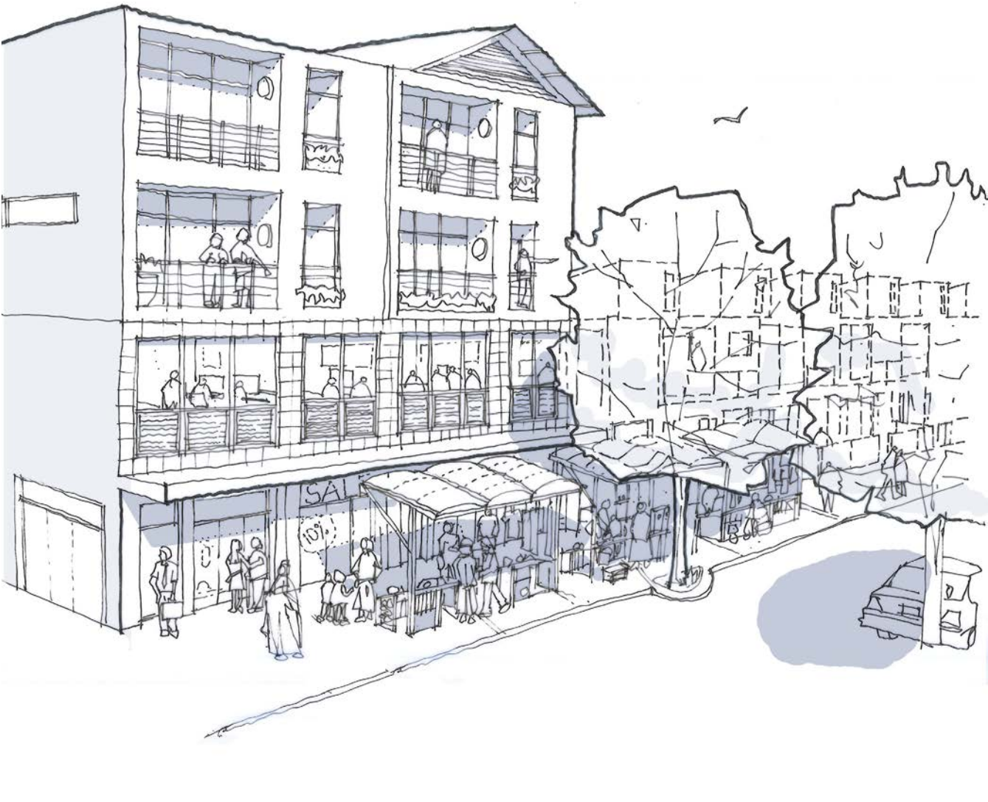

public facilities

PS5.2. A proposal must make of its site and seek to optimise its development potential through the

efficient use

intensification of built form

(in terms of height and coverage) in response to the elements of the urban structure. A and activities should be proposed where viable and appropriate and the arrangement of uses on the site, or within buildings should respond positively

mix of uses

to the attributions of the particular site and its surrounding urban context.

PS5.3. like Sustainable Urban Drainage Systems (SUDS), play grounds, allotment gardens etc. to use space more effectively and increase shared use.

Combine open space uses

PS5.4. Ensure that urban blocks, individual erven, buildings and spaces are and designed so that they can be to accommodate other uses and meet the needs of future generations. For instance: at the urban level- urban blocks should be a minimum of 30m deep to allow them to accommodate a range buildings types; and

generously proportioned

adapted

at a building level - circulation cores should be located appropriately and floor-to-ceiling heights should allow for the adaptive reuse of the building over time.

• Cape town Densification Policy, 2012

RELATED POLICIES / INFO

• Development Management and Information Guideline

Series – Booklet 7 Landscape Plans, 2009 Series

• Summary Guidelines and Standards for the Planning of City of Cape Town Social Facilities and Recreational Spaces, 2010

• Tall Building Policy, 2013

**OBJECTIVE 6: ENSURE ENCLOSURE AND POSITIVE INTERFACES ONTO THE PUBLIC REALM**

*A quality public environment is further reinforced through the spatial arrangement of urban blocks, the appropriate scale and massing of the built form, the definition of space through enclosure as well as the positive interfaces between buildings and the public realm and. Therefore:*

PS6.1. The of new streets, urban blocks, plots and buildings should recognise the historic street pattern, reinforce the existing or proposed urban structure and respond positively to environmental conditions such as orientation, rain and wind patterns so as to maximise levels of comfort for the pedestrian and make places that are pleasant to be in.

orientation

PS6.2. Locate buildings so that they have a

positive relationship

with the street. Wherever possible buildings should be located as close as possible to the street boundary and/

define

or along the edge of an open space to and provide

to the public realm. Where the use of the building allows, the facade of the building should be used to define the public realm and public spaces.

enclosure

PS6.3. between the public and private realms to ensure active and lively building frontages. Blank facades and parking fronting onto the street should be avoided.

Design and articulate the interface

PS6.4. should not be located on the first two levels above ground. Where this is unavoidable it should be wrapped with active uses along the interface with the public realm.

Parking structures

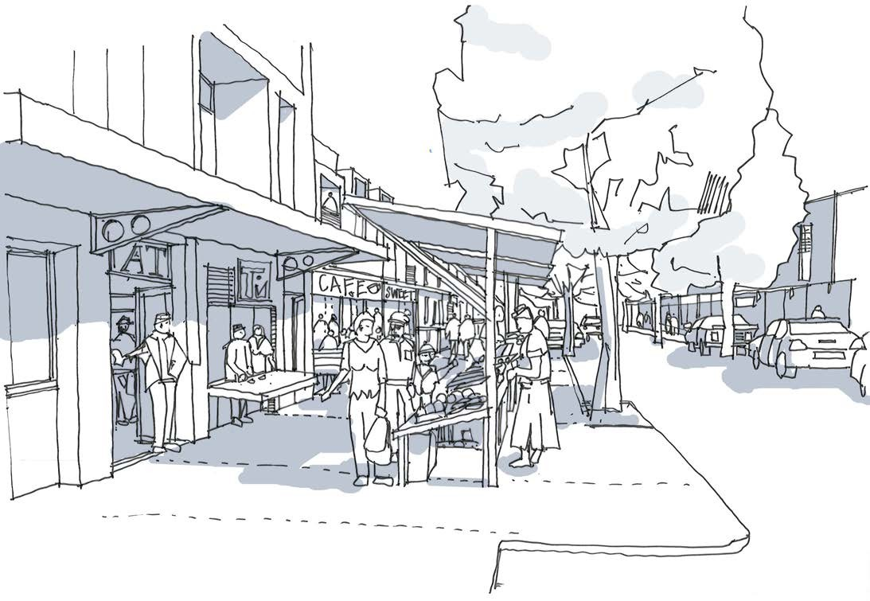

• Cape Town SDF, 2012

RELATED POLICIES

• Tall Building Policy, 2012

• Design Guidelines For A Heritage Context - City of

Cape Town Heritage Advice Pamphlet, 2009 series

**OBJECTIVE 7: DEVELOPMENT SHOULD RECOGNISE AND RESPOND APPROPRIATELY TO INFORMALITY**

*Informality is a complex and inseparable part of our urban society which has particular implications for urban design and urban development. The informal economy in particular is not limited to poor neighbourhoods or poor communities. It has a complex and interdependent relationship with formal elements of the economy and elements of urban infrastructure. Informal settlement too is a response to the availability of land and access to opportunities, infrastructure and services. Accommodating the links and interdependencies between the formal and the informal during the design process of a development proposal, is key to developing a city which responds to the complex realities of our urban society. This objective seeks to improve the living conditions of the poor and support the livelihood strategies through strategic investment in the public realm and by recognising and responding proactively to informality. Therefore:*

PS7.1. to informality at site level by focusing on interventions within the public environment and in response to the ways the sites are used on a daily basis. Such interventions could include the formalisation of movement routes, the provision of public facilities and

Respond proactively

the provision of basic infrastructure and services in a manner that creates social gathering places or places to

PS7.3.

wherever possible in the layout of new townships by zoning land appropriately and in response to opportunities and constraints of a particular site. Further ensure that programmes and strategies are put in place so that the spaces and buildings are used by the communities they were intended to serve and on a sustainable basis.

Plan for economic activity and sustainable livelihoods

trade.

PS7.2. around areas where informal trading is common and within informal settlements by upgrading the public environment to mitigate natural hazards and man-made risks, by ensuring adequate access for emergency services, regular fire breaks and public lighting in high crime areas.

Prioritise public health and safety measures

PS7.4. and informal traders around higher nodes and around public

Plan for micro enterprises

order activity generators (urban

institutions and interchanges) which attract high levels of pedestrian traffic. This may include identifying locations

for trading stalls and ensuring small units within the retail mix.

• Informal Trading Bylaw

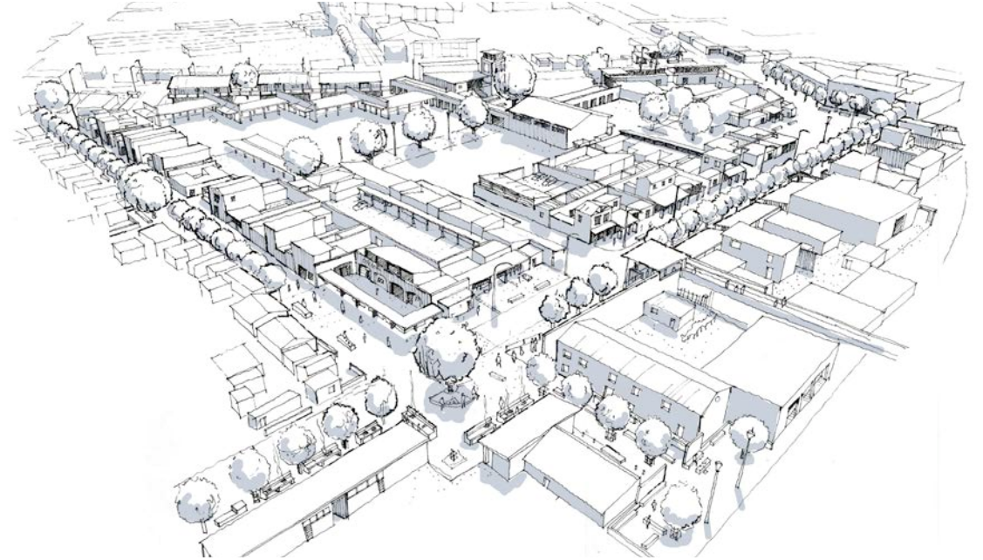

• Informal Trading Policy, 2013

• Housing Policy – Upgrading of Informal Settlements

RELATED POLICIES

Programme

• Cape Town Zoning Scheme, 2012

**OBJECTIVE 8: DEVELOPMENT SHOULD PROTECT, VALUE AND ENHANCE THE NATURAL ENVIRONMENT THROUGH SUSTAINABLE DESIGN**

*The focus of this objective is on the relationship between the natural environment and built form. The intention is to ensure that developments respond positively to natural features and ecosystems, improve water quality, reduce energy usage and minimise waste production, so that the material and spatial needs of society are kept in balance with the requirements of nature. To achieve this it will be necessary to:*

PS8.1. green open space systems and ecologically sensitive areas. Ensure that these are suitably into the

Protect and enhance environmental resources,

integrated

design of new developments with suitable setbacks and buffers and ensure that buildings to open space systems through the arrangement of built form and the design of its interface with its associated landscape.

relate positively

PS8.2. Ensure the

continuity of the city’s open space network

by arranging development and new open spaces in such a way that they become viable and meaningful spatial connections which support biodiversity.

PS8.3. Start the design process by understanding and working

in harmony with the of the site and apply the principles of Water Sensitive Urban Design (WSUD) so as to arrive at a layout that is water sensitive and space efficient, minimises the disruption of the natural hydrological cycle and works together with other related gravity systems such as sewerage.

natural drainage patterns

PS8.4. Ensure the maintenance and management of open space systems are considered during the design stages.

• Stormwater Management Planning and Design Guidelines

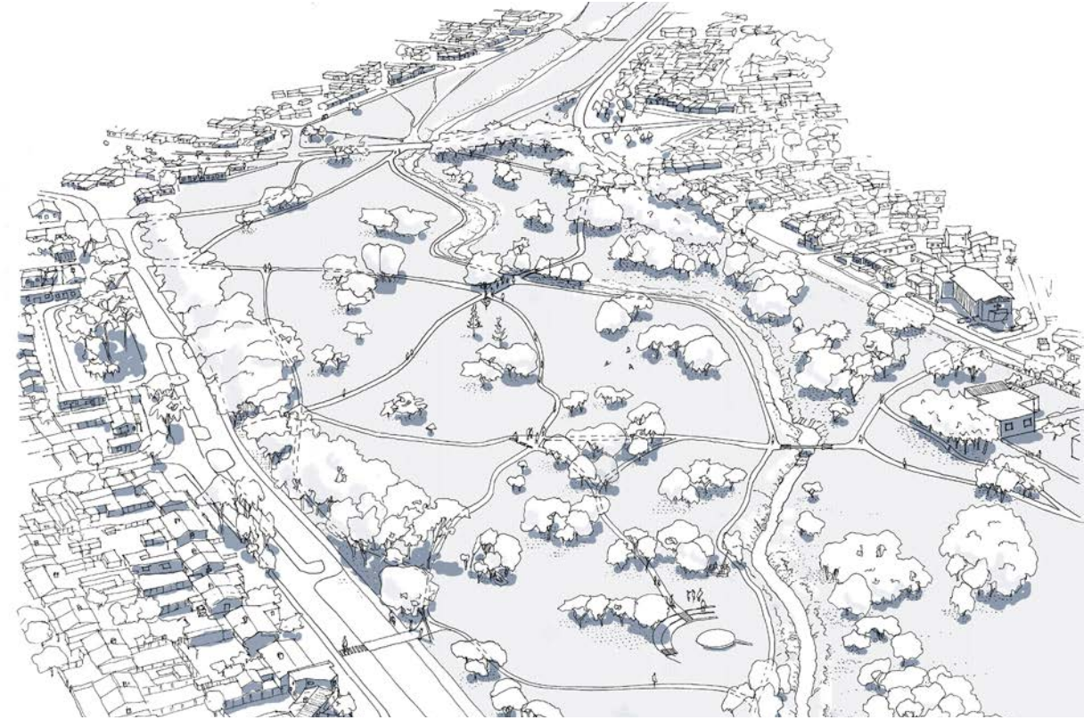

for New Developments, 2002

• Stormwater Management of Slopes Adjacent to Natural

Areas, 2003

• Management of Urban Stormwater Impact Policy, 2009

• Floodplain and River Corridor Management Policy, 2009)

RELATED POLICIES / INFO

• Green Building Guidelines, 2008

• Tree Policy,2002

**OBJECTIVE 9: DEVELOPMENT SHOULD RESPECT AND ENHANCE THE HERITAGE, CHARACTER AND UNIQUE IDENTITY OF THE CITY AND ITS NEIGHBOURHOODS**

*The qualities which come together to give a place a particular character or identity is what distinguishes one part of the city from another. This character or ‘sense of place’ is influenced by natural features, land use, landmarks, heritage and built form as well as layered, non-spatial qualities such as cultural practice and memory. Because character and identity are so important, these qualities need to be acknowledged, respected and enhanced through design and new development that is contemporarily appropriate and in harmony with the receiving environment. To achieve this it will be necessary to:*

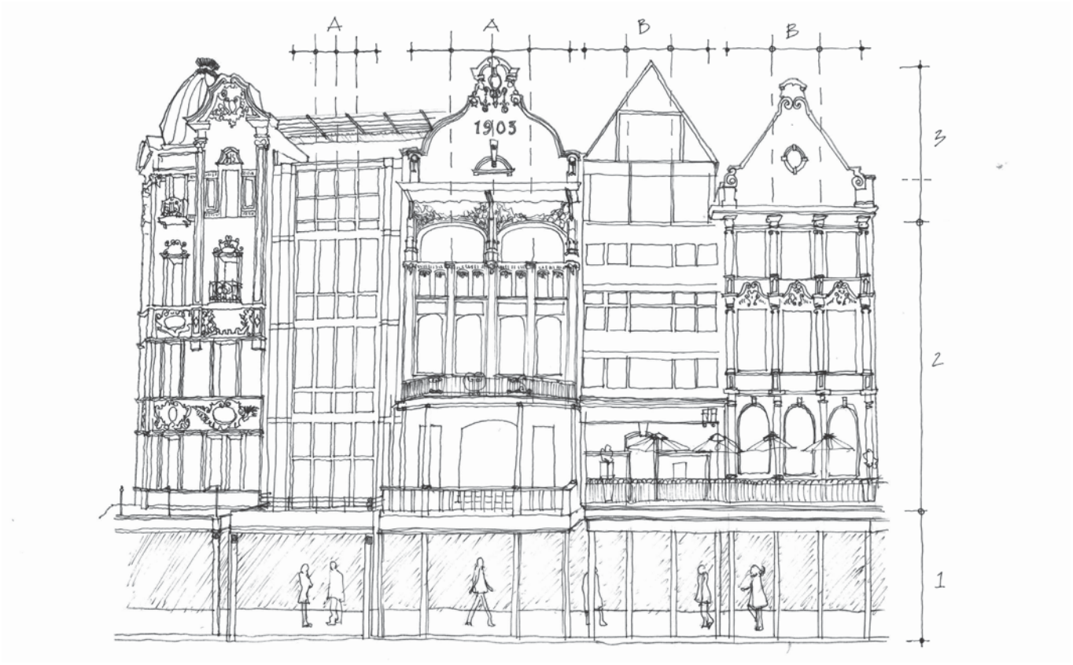

PS9.1. which form part of a neighbourhood’s identity (including important vistas, view corridors and views of local landmarks)

Safeguard the integrity of the natural features

when considering development proposals. These qualities need to be identified during the design process and it needs to be demonstrated how the intrinsic qualities of the place will not be detrimentally transformed through development;

PS9.2. of the city and integrate new proposals within their existing context by: knitting developments into the historic grain and open space system of the area, retaining the key elements of

Respect the heritage and cultural landscape

the cultural landscape, and creatively adapting buildings of historic or architectural value, responding sensitively in terms of building height, massing and the placement of

|  |  |  |  |  |
| --- | --- | --- | --- | --- |
| buildings on the site; continuing or introducing vertical | • | City of Cape Town’s Heritage Advice Pamphlet series, | • | Central City Development Strategy – Development |
| and horizontal rhythms within the streetscape; and complementing the style and material palette of adjacent | • | 2005  Outdoor Advertising Bylaw, 2009 | • | Guidelines for Land Use Management, 2011  Various Heritage Area Studies |
| technologies and modern detailing. | • | Tall Building Policy, 2013 | • | Cultural Heritage Strategy, 2005 |

• Scenic Drive Policy, 2002

RELATED POLICIES / INFO

• City of Cape Town’s Integrated Metropolitan Environmental

Policy (IMEP) Cultural Heritage Strategy, 2005

• Sky Bridges Policy, 2012

• Central City Development Strategy Vision and Action

Plan, 2008

buildings in a contemporary manner, by using appropriate

**4.0 IMPLEMENTATION**

The Urban Design Policy will be effective from the date it is approved by Council and will not be retrospectively applied to applications that are already in the system. The Policy will be applied within the City’s existing development application process and will need to be considered by officials in the assessment of development applications outlined in Section 3.1.

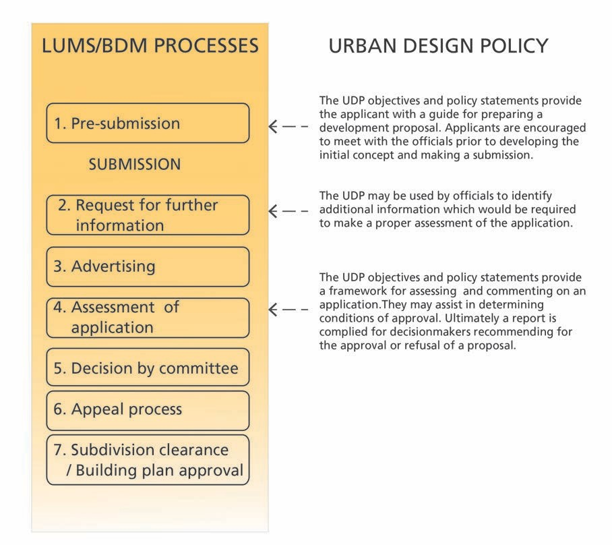

It is the applicant’s responsibility to ensure that where parallel processes are required (in terms of other pieces of legislation), that these are integrated as far as possible and to ensure that design considerations are considered in order to streamline all levels of approvals and minimise risk.

Prospective applicants who are considering projects to which the policy would apply are strongly advised to engage the City at an early stage in pre-submission consultation. For the purposes of such pre-submission engagement and in order for the City’s officials to provide meaningful input at such as session, it is proposed that prospective applicants voluntarily prepare a design statement which should include:

• A vision and objectives for the proposed development;

• A contextual analysis providing an understanding of the site in it’s context and outlining how contextual factors have informed the response to the site and brief;

• A design framework supported by diagrams, plans and illustrations indicating how the development is organised in terms of access, land use, massing and public interfaces; and

• A summary of how the objectives and principles of the City’s various policies have been addressed.

Where applicants have not made use of the suggested pre-submission consultation engagement opportunity, they should still look to address the urban design objectives raised in this policy document and structure their motivation in the manner suggested above as a design statement.

**5.0 POLICY EVALUATION, MONITORING AND REVIEW**

It is proposed that the Policy substance (Objectives and Statements) will be reviewed periodically in order to ensure that they are relevant, respond appropriately to development trends and align with the goals and objectives of the Integrated Development Plan. The operational mechanisms for implementation of the Policy, may however be determined, reviewed and amended by the Executive Director: Economic, Environmental and Spatial Planning (EESP) as and when deemed appropriate in line with the system of delegations.

The monitoring and evaluation of the effectiveness of the Policy in achieving its objectives will be measured specifically in relation to the applications which fall into the scope of application - and will be measured against the following goals:

**5.1 The effectiveness of the policy in facilitating approvals processes**

The effectiveness of the Policy in facilitating the approvals process from a procedural perspective will be measured, amongst others, against the following:

• The increase in the number of submissions where pre-submission consultation has taken place and where applicants have been given direction in relation to how their proposals could be developed in order to meet the requirements of City policies;

• The regularity of requests for further information by Case Officers, after applications have been submitted on the basis that insufficient information has been provided to enable an urban design assessment to be undertaken;

• The decrease / increase in number of applications which have not been processed within the required timeframe as a result of changes being required as a direct result of noncompliance with the Urban Design Policy;

• The decrease / increase in the number of post-submission

consultations to resolve issues related to the Policy; and

• Feedback from District Managers and PBDM Section Heads on the implementation of the policy.

The review process could be informed by factors such as:

• The number and typology of applications which were referred to political decision-makers on the grounds of noncompliance and how many have been turned down; and

• The policy statements which are most often cited as the reason

for proposals not being compliant with Policy.

**5.2 The effectiveness of the policy in improving the quality of the urban environment**

As urban development processes take time to materialise, the impact of the Policy will only become evident after developments have been built and are occupied. Qualitative assessments are also complex and difficult to undertake due to the subjective tendency of this type of assessment. The effectiveness of the policy in achieving this goal will therefore need to be measured through a range of mechanisms including:

**Independent / expert panel reviews**

Independent review panels comprising of industry experts could be assembled to assess the impact of the Policy on the evolution and improvement of development proposals through the approvals process. The views and reflections of the panel could be used to inform the review of the Policy irrespective of whether applications have been approved or not.

**Benchmarking and indicators**

A set of performance indicators could be developed to provide a consistent and robust tool for measuring the quantitative and qualitative impact of the policy over time. These indicators would need to be developed with input from a range of different stakeholders and interest groups.

**Urban design awards**

In order to recognise projects which are exemplary and demonstrate how the principles of the Policy have been implemented, the City will consider making awards to projects and their design team for the contribution their development has made to the urban environment.

**Post implementation evaluation and case studies:**

Case studies could be undertaken by independent consultants after developments, which have been subjected to the policy, are complete and occupied. The case studies could compare developments which have deviated from the policy to similar development which are compliant with the policy or where the policy has been enforced. To ensure objectivity the case studies should include:

• Developer surveys;

• Property market surveys;

• Design professionals surveys;

• Surveys of officials involved in the approvals process;

• End user perception surveys; and

• Public perception surveys.

**6.0 GLOSSARY, DEFINITIONS AND TERMINOLOGY**

**Accessibility**

The degree to which a site, building, service, or environment is accessible to people, irrespective of who they are or how they move.

**Active frontage/ interface**

Refers to street frontages where there is an active visual engagement between those in the street and those on the ground floors of buildings. This quality is assisted where the front facade of buildings, including the main entrance, faces and opens towards the street, and also where ground floor uses accommodate activities that provide a level of interaction between pedestrians and the building uses including cafes/restaurants, shops, offices etc.

**Adaptability**

The capacity of a building or space to be changed so as to respond to changing social, technological and economic conditions.

**Blank facades**

An elevation of a building which has no door or window openings.

**Built form**

The shape and massing of development. Built form relates to qualities such as density or quantum of development (often referred to as massing), coverage (how much of the site is built up), building height, the distance from property lines.

**Community facility**

A building or structure which houses a service to the public or a select group or community. Such facilities include crèches, religious institutions and clubs. Full public access to such facilities is often restricted or limited.

**Context**

The broader environment within which a development or site is located. Context is a broad term and can refer to natural systems, topography, the social and economic environment, the built environment, access, public institutions, public space, and public utility services.

**Cultural landscape**

A physical area with natural features and elements modified by human activity and resulting in patters of evidence layered over time in the landscape. These qualities give a place distinctive spatial, historical, aesthetic, symbolic and memorable character.

**Desire line**

An imaginary line linking facilities or places. Desire lines become evident when watching people move through an area and often visible through informal footpaths across open spaces.

**Diversity**

A place which offers variety and choice in terms of land use activity and mobility options.

**Enclosure**

An experience in which a pedestrian feels sheltered within the publi realm. Buildings, walls, trees, landscaping and street widths are all factors in creating a sense of enclosure.

**Form**

The layout (structure and urban grain), density, scale (height and massing), appearance (materials and details) and landscape of development.

**Higher order structuring route**

Streets or movement corridors which play a critical role in determining the structure of the urban environment. The following are characteristics of structuring routes: high levels of spatial continuity and access; a concentration of mixed land uses and activities; contain higher order public facilities; development is generally more dense; and an intensity in the movement of people, goods, public transport and private vehicles.

**Integration**

The spatial and functional linking of areas of development and their inhabitants. Integrated areas form a coherent physical whole where,

in livability terms, the whole is greater than the sum of its parts.

**Intensity**

Refers to achieving a greater spectrum of mixed land uses through increased use of space, both horizontally and vertically, within existing areas, properties and new developments.

**Landmark**

A building or structure which is recognisable and stands out from its background by virtue of height, size or some other aspect of design.

**Landscaped**

The intentional arrangement of soft (trees and planting) and hard elements within a space.

**Layout**

The way buildings, routes and open spaces are placed in relation to each other.

**Legibility**

The degree to which the qualities or structure of a neighbourhood or building can be perceived and understood.

**Massing**

The combined effect of the arrangement, volume and shape of a building or group of buildings in relation to other buildings and spaces.

**Node**

A point within the urban system where activities, land uses and development is concentrated. Nodes are typically located where levels of accessibility are high and at the confluence of movement and public transport routes. The size and extent of a node depends, on the nodes location within the larger urban system and on the limitations of a pedestrian to move within it. A node generally has a sphere of influence of between 200 - 400m from its centre.

**Overhang**

A part of a building or structure which extends beyond its supporting structure or over a property boundary. Examples include balconies, and roof eaves.

**Overlooking/ overlooked**

When a building has doors and windows positioned in such a manner that they allow the occupants inside a building to visually connect with the spaces outside of that building.

**Passive surveillance** is the casual observance of public and private areas by people in the course of their normal activities.

**Permeability**

The degree to which an area has a variety of pleasant, convenient and safe routes through it.

**Positive interface**

See definition for active frontage/ interface.

**Public facility**

A building which is owned, built, managed and maintained by a governmental institution or which provides a service on behalf of government.

**Public good**

The condition in which all citizens are able to enjoy in the benefits urban living to the extent that each individual’s actions does not lead to a subtraction or diminishment of any other individual’s or groups ability to act or enjoy the same benefits.

**Public realm/ environment**

The collection of physical and nonphysical elements which are accessible or impact on the general public. Some aspects of the public realm are privately owned and managed. The public realm includes amongst others all forms of media, open spaces and streets.

**Public space**

The public space includes the natural and built environment used by the general public on a day-to-day basis such as streets, plazas and parks.

**Streetscape**

The distinguishing character of a particular street as created by the elements at ground floor, including building frontages, setbacks, materials, form, road space, landscaping, street furniture, etc.

**Significant negative impact**

In relation to development, when a proposal has the potential to: negatively impact on the structure of a neighbourhood or part of the city; detrimentally alter the character of a neighbourhood; cause undue inconvenience for public access; limit adjacent property owners ability to enjoy or realise the rights they are entitled to; or undermine the market value of an adjacent properties of a neighbourhood as a whole.

**Surveillance**

The ability of a person or thing to observe and control activities within a defined space. Surveillance may be achieved passively - by providing physical opportunities to connect a surveyor to a space; or through active or artificial means - through CCTV or law enforcement patrols.

**Sustainable Urban Drainage Systems (SUDS)**

A branch of Water Sensitive Urban Design which focuses specifically on stormwater management.

**Vibrant**

A place characterised by energy and activity.

**Views & vistas**

A visual quality within the landscape/urban landscape that typically provides some visual amenity. The importance of the view typically relates to the level of amenity the view provides. A vista is a corridor view usually framed by an avenue of trees or buildings.

**Urban grain**

A description of the density and nature of development which results from the arrangement of buildings in space. The term urban grain is used at a variety of scale and can refer to the density of urban blocks, streets, plot or buildings footprints.

**Urban structure**

The structuring framework of a region, town or precinct, showing relationships between zones of topography, natural environments, activities, built form and open space. It encompasses broader systems including transport and infrastructure networks.

**Water Sensitive Urban Design**

An approach which seeks to ensure that development in urban areas is holistically planned, designed, constructed and maintained so as to reduce negative impacts on the natural water cycle and protect aquatic ecosystems. Sustainable water supply, sanitation and stormwater management are encompassed within the WSUD approach.

**Acronyms and Abbreviations**

CTSDF Cape Town Spatial Development Framework EESP Economic, Environmental and Spatial Planning IDP Integrated Development Plan of the City of Cape

Town

LUMS Land Use Management System

LUPO Land Use Planning Ordinance

NHRA National Heritage Resources Act, 1999, (Act 25 of 1999)

NEMA National Environmental Management Act, 1998, (Act 107 of 1998)

PBDM Planning and Building Development

Management Department of the City

(The department responsible for processing land use and building applications)

SDF Spatial Development Framework

SDP Site Development Plan

SPUD Spatial Planning and Urban Design

SUDS Sustainable Urban Drainage System

WSUD Water Sensitive Urban Design

**References**

Cape Land Use Planning Ordinance, No 15 of 1985

City of Cape Town, Cape Town Spatial Development Framework,

2012

National Building Regulations and Building Standards Act, 1977, (Act 103 of 1977).

<http://www.udg.org.uk/about/what-is-urban-design>

**7.0 ACKNOWLEDGEMENTS**

*The preparation of the Urban Design Policy has taken over 3 years and has benefited from the valuable input of a number of individuals and stakeholders. This included representatives of various line departments who formed part of the Project Management Team (PMT); a working group members of PDBM officials who will be tasked with implementing the policy; and members of an External Review Panel, which included members of the Urban Design Institute of South Africa (UDISA), members of the Cape Institute for Architecture (CiFA) Cape Members of the Insitute of Landscape Architects of South Africa (ILASA)and members of the South African Planning Institute (SAPI).*

**Project Management Team (City Officials)**

Gideon Brand PBDM Head: Land use Management Jaco vd Westhuizen PBDM: Dev. Processes and Policies Schalk de Jager PBDM

Teuns Kok Non-motorised Transport

Tony Vieira Transport

Nuran Nordien Transport Impact assessment Tom Pressinger IRT Project Implementation Karesha Naidoo IRT Project Implementation Kapil Singh IRT Project Implementation Johan Cornelius Environment Resource Man. Herman Steyn New Settlements

Jens Kuhn Housing Land & Forward Planning

Rod Arnold Catchment Management Andre Human Property Management Tania Lewis Property Management Alicia Bosman City Health

Bertie Byker Roads & Stormwater

John Bennett City Parks Bradley Burger City Parks Alastair Graham VPUU Alfonso van Vuuren Solid Waste

Charles Parkerson Economic and Human Dev. Zuko Mdingi Economic and Human Dev. Paul Williamson Business Areas Management

**Planning & Building Development Management**

**Reference Group**

Karen Patten Cape Flats District

Rafiq Allie Mitchells Plain/Khayelitsha

Pieter Koekemoer Eastern District Randolph Daniels Eastern District Eloise Rousseau Southern District Paul Heydenrych Southern District Stuart Denoon-Stevens Southern District Ray Bergman Table Bay District Greg September Table Bay District Friedrich Durow Table Bay District Louis Coetzee Table Bay District Erhard Pienaar Tygerberg District Charles Rudman Northern District Karen Patten Central District Alicia Visagie Blaauwberg District Randolph Daniels Helderberg District

**External review panel of subject experts**

Tiaan Meyer Urban Design Institute of SA Bobby Gould-Pratt Urban Design Institute of SA Matthew Gray Urban Design Institute of SA Fabio Todeschini Cape Institute for Architecture Simmy Peerutin Cape Institute for Architecture Rudi Botha Cape Institute for Architecture David Gibb Member of ILASA

Claire Burgess Member of ILASA Jason Turner Member of ILASA Mareza van Rensburg Member of ILASA Anton Lotz SA Planning Institute

**Commentators on the policy (during public consultation)**

Civic Associations

• Hout Bay Residents’ and Ratepayers

• Walmer Estate Residents Forum

• Kuilsriver Civic association

Private Sector

• ARUP South Africa’s Integrated Urbanism Team

• Urban Collaborations

• V&A Waterfront

NGO’s

• Future Cape Town

• Open Streets

• Development Action Group

Tertiary Institution Staff

• Prof. Henri Comri

• Prof. Wolfgang Preiser

Individuals

• Célinda Burger

• Clare Burgess

• Eugene da Silva

• Garth King

• Tony Markewicz

• Erhard Pienaar

• Renier venter

• Karen Gottschalk

• Justine Hansen

The Institute of Landscape Architects in South Africa